Minimum Wage Policy and Poverty Outcomes: Evidence from State-Level Data

Calvin T Burzynski
Denison University
DA 401: Seminar in Data Analytics
Dr. Zhe Wang
12/14/2025

Abstract
Minimum wage policy is widely used as an anti-poverty tool, yet empirical evidence on its effectiveness remains mixed, particularly with respect to poverty outcomes rather than employment or wages. We investigate whether raising the minimum wage at the state level reduces poverty among full-time low-wage workers. Previous studies show steady income increases but conflicting results regarding poverty consequences, especially when household characteristics and labor market factors are taken into account. To account for heterogeneity policy adoption across states, we implement a difference-in-differences (DiD) approach with staggered treatment scheduling using state-year data from 2010 to 2023. Our empirical methodology integrates robustness checks using lag structures and state-specific trends, event-study analysis, and two-way fixed effects models. This yields post-treatment results that indicate impacts on poverty are minimal and imprecisely estimated, arising gradually rather than immediately after policy changes. Also, there was no evidence of differential pre-treatment trends. Overall, our findings indicate that raising the minimum wage by itself only slightly lowers measured poverty, highlighting the significance of more comprehensive economic circumstances and supplementary legislative measures.

Introduction
In the United States, minimum wage legislation has long been used to increase incomes at the bottom of the wage distribution and alleviate poverty among low-income workers. Although a large body of research shows that raising minimum wage has positive income impacts, there is conflicting data whether or not these policies actually reduce poverty. This distinction is crucial because poverty varies conceptually from earnings or employment and is a major policy concern. Since many states have raised the minimum wage above the federal minimum during the past 20 years, there has been variance in the timing and scope of policy, which has spurred additional empirical research into the wider welfare implications of minimum wage policy.
One major problem arises in relating minimum wage hikes to poverty outcomes. That is, poverty is a household-level metric impacted by factors other than hourly pay. Whether someone is over or below the poverty threshold depends on a variety of factors, including the makeup of their household, the number of earners, the number of hours worked, the state of the local labor market, and their involvement in social safety net programs. Many people living in poverty do not work full-time, as noted by Sabia and Burkhauser (2010), which limits the ability for pay floors to significantly alleviate poverty. Wage increases may not be enough to raise households beyond the poverty line, even for full-time low-wage workers, especially in high-cost regions or homes with dependents. Additionally, much discussion has been centered around the minimum wage needing a substantial increase, as corporate profits have risen substantially in comparison to the wage floor.
These difficulties are highlighted in empirical findings. According to numerous studies, raising the minimum wage boosts workers’ incomes but has little to no impact on poverty rates (Dube, Lester, & Reich, 2010). Other research indicates that poverty responses may vary by demographic and develop gradually rather than immediately after policy changes. While Winkler et al. (2025) reveal that linked outcomes like food insecurity may respond even when measured poverty does not. The majority of the research points to the possibility that minimum wage laws may have an indirect impact on poverty rather than acting as a consistent anti-poverty measure.
Methodological issues arise when attempting to estimate the causal effect of minimum wage hikes on poverty. Concerns regarding heterogeneous treatment effects and bias in traditional two-way fixed effects difference-in-differences models are raised by the fact that states implement minimum wage hikes at various periods and under different economic conditions (Bilinski & Hatfield, 2020). These issues are addressed by recent developments in difference-in-differences methods, which enable adjustment treatment scheduling and dynamic effects. Callway and Sant’Anna’s (2021) methodology is especially useful for researching poverty outcomes, which may react slowly to policy changes.
Using state-year data from 2010 to 2023, we investigate whether raising the minimum wage at the state level reduces poverty among full-time low-wage workers. Our empirical approach includes event-study analysis, staggered difference-in-differences estimates, population-weighted two-way fixed effects models with covariates, and robustness tests using lagged policy impacts, state-specific trends, and alternative sample constraints. We observe that post-treatment impacts on poverty are moderate and imprecisely calculated, and we find no evidence of distinct pre-treatment trends, which are visualized in Figure 1. These findings imply that minimum wage hikes alone result in limited reductions in measured poverty among full-time low-wage workers.

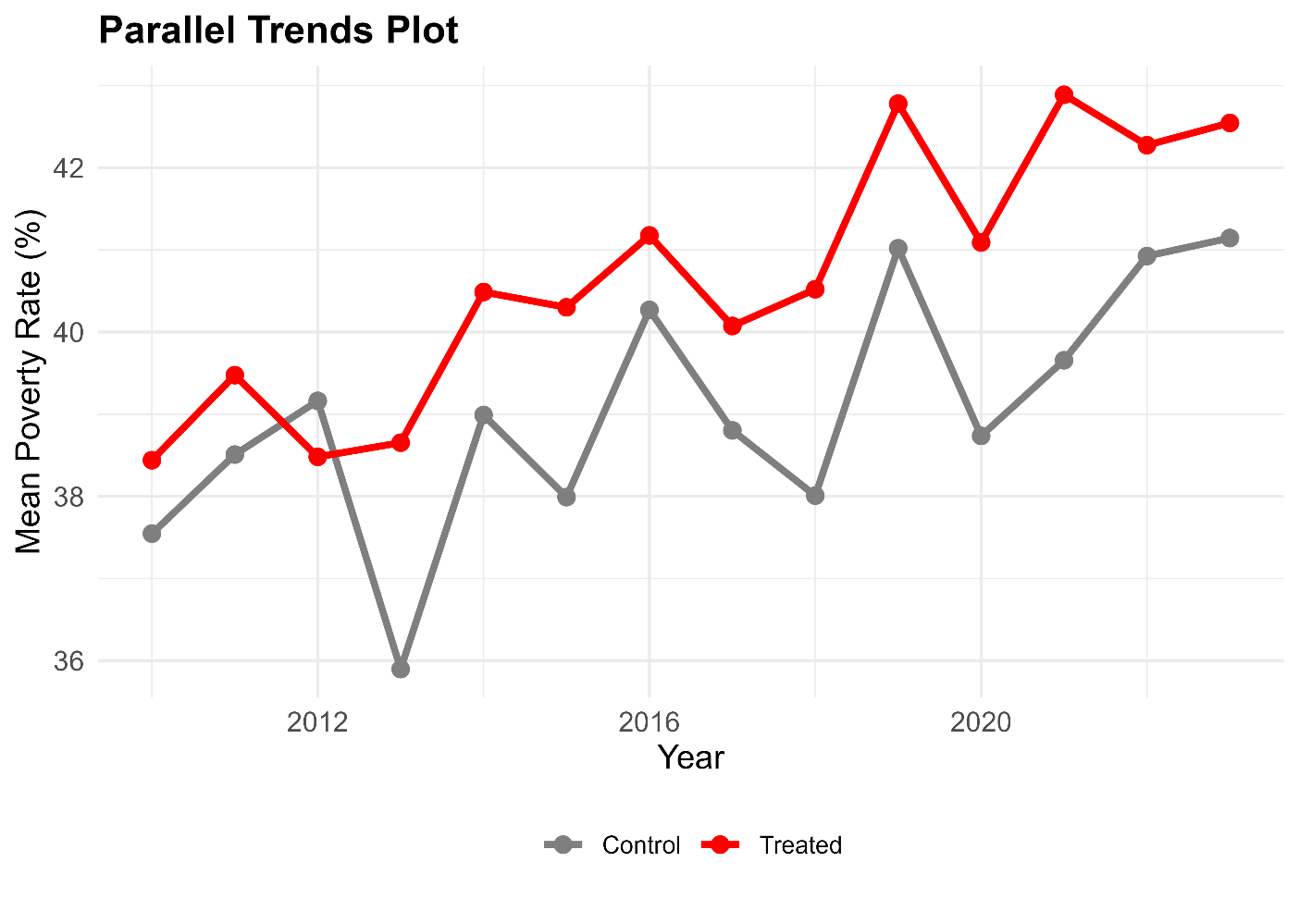

Figure 1: Parallel trends in poverty rates for treated and control states. This graph highlights the average poverty rates over time for treated and control states prior to treatment assignment. While treated states had greater poverty rates on average, pre-treatment trajectories are roughly identical, giving visual support for the parallel trends assumption that underpins the difference-in-differences design.

Literature Review
A growing number of studies on minimum wage policies assess outcomes rather than employment, such as poverty, material suffering, and more general well-being indicators. The data is inconsistent generally, and a large portion of this discrepancy may be attributed to variations in demographics being targeted, the results under study, and policy environment. Changes in minimum wage policy can increase wages without necessarily pushing household over the poverty line, particularly in cases where poverty status is determined by household composition, hours worked, and non-wage sources. While acknowledging that poverty is a household-level result, this encourages concentrating on a demographic that is most directly exposed to pay floors, such as full-time low-wage workers.
Whether raising the minimum wage significantly lowers measurable poverty is a central point of contention. Based on Sabia and Burkhauser’s (2010) analysis of U.S. policy changes, raising the minimum wage has no effect on poverty because many low-wage workers live in homes that are over the poverty line or because the benefits are insufficient to change the individual’s status. On the other hand, Arranz and García-Serrano (2025) discover that, although the impacts varied by location, a significant national minimum wage rise in Spain increased household income and decreased poverty. When combined, these studies show that the consequences of poverty might vary depending on the circumstances, including home structure, baseline labor market conditions, and the size of the pay boost. Furthermore, they emphasize the significance of focused U.S. investigation rather than supporting that findings apply to other contexts.
Even when official poverty measurements reveal tiny or ambiguous changes, research demonstrates that minimum wage policies may have an impact on material hardship and household stability. Higher state minimum wages are linked to less food insecurity among households with children, according to Winkler et. al (2025). This suggests that wage floors can enhance daily economic security even if they do not continuously raise households above the poverty line. Narain and Zimmerman similarly document associations between minimum wage changes and health outcomes across demographic groups. This more comprehensive information is important for interpretation since it does not necessarily imply that minimum wage legislation has no welfare impact if poverty effects are muted in the findings. It might imply that, in comparison to mechanisms by minimum wage are implemented, the poverty level is a potentially weak indicator.
Another constant result is heterogeneity, which exists in both policy contexts and estimated impacts. The importance of designs that compare more comparable geographic locations is highlighted by Dube, Lester, and Reich (2010), who demonstrate how the construction of comparison groups might affect the estimated minimum wage impacts. Wang, Phillips, and Su (2019) also point out that treatment effects might vary by state, demonstrating that national averages can mask significant variances. This heterogeneity is the reason for the emphasis on staggered adoption, dynamic effects, and robustness checks within this study. If treatment effects differ by state or evolve over time, methods that assume constant effects can mislead. The estimation of minimum wage studies in situations where adoption is staggered and impacts may be varied is strongly impacted by recent methodological work. In line with the focus on identifying parallel trends rather than assuming them, Bilinski and Hatfield (2020) offer a methodology assessing whether pre-treatment differences are substantially insignificant. In their evaluation of contemporary difference-in-differences techniques, Feng et. al (2024) place a strong emphasis on robustness, diagnostics, and estimator selection in applied policy contexts.
Ultimately, the literature points to three conclusions that influence the direction of this study. First, as seen by varying results across settings and outcomes, the impact of minimum wage hikes on poverty is not certain and depends on population and circumstance. Second, careful interpretation is necessary because minimum wage policies may have an impact on welfare through avenues that the official poverty measure does not fully reflect. Third, diagnostic testing and estimator selection are crucial to credibility due to heterogeneity and delayed policy implementation. Using panel methods with covariates, staggered difference-in-differences estimation, and event-study dynamics, along with explicit pre-trend diagnostics and inference choices appropriate for state policy analysis, this paper assesses the effect of state minimum wage increases on poverty reduction among full-time low-wage individuals.

Data and Measures
A state-year panel encompassing the years 2010 through 2023 is used as the primary dataset. The dataset consists of N ≈ 700 state-year observations, representing 50 U.S. states observed over the scope of the study. The state-year serves as the unit of observation. The American Community Survey (ACS) microdata, which may be accessible at IPUMS USA, is used to build outcome and demographic variables. The U.S. Department of Labor provides statutory minimum wage statistics, while the Bureau of Labor Statistics' Local Area Unemployment Statistics are used to gauge labor market conditions. A real minimum wage measure (min_wage_real) is obtained by converting nominal minimum wage values (min_wage_nominal) to real terms using the CPI-U (CPI-U).
The sample consists of individuals aged 18-64 who report working full-time, defined as at least 35 hours per week (UHRSWORK ≥ 35) and at least 50 weeks in the previous year (WKSWORK2 ≥ 6). To ensure reliability with household-based poverty assessment, those living in group quarters are excluded. ACS person weights (PERWT) are used to aggregate person-level observations to the state-year level, guaranteeing population-representative values.
Also, the sample utilizes the ACS poverty ratio (POVERTY), which compares total household income to the federal poverty threshold modified for family size and composition, is used to determine a person's level of poverty. The state-year poverty rate for full-time low-wage workers is the main result. The sample is restricted to those whose family income is at or below 150 percent of the federal poverty level (POVERTY ≤ 150) to concentrate on workers at or near the poverty threshold. This indicator's weighted mean is calculated at the state-year level and given as a percentage.
The key policy variable represents the timing of state minimum wage hikes using a staggered treatment paradigm. The first year when a state's statutory minimum wage rises in comparison to its own previous year level is known as treatment (treated = 1). After a state receives treatment, it continues to get treatment in every year that follows. States are categorized as never treated if they do not implement any increases during the study period. This approach avoids confusing treatment status with whether the minimum wage surpasses a set government threshold and isolates policy changes rather than absolute salary levels.
For estimation, the treatment indicator is transformed into a set of event-time indicators (event_time) indexed relative to the first year of a minimum wage increase, with the year immediately preceding treatment serving as the omitted reference category (event_time = -1). Given that poverty outcomes may change gradually, this framework makes it possible to explicitly assess pre-treatment trends and estimate dynamic post-treatment impacts.
Finally, time-varying state-level variables compiled from ACS microdata are included in the models. The yearly unemployment rate (unemp_rate) is used to account for labor market variables. The percentage of non-white full-time low-wage workers (share_nonwhite) and those with less than a high school education (share_lowedu) are used to measure the demographic makeup. The percentage of people who get SNAP assistance is used to calculate social safety net participation (share_snap). To improve numerical stability and interpretability, all factors are standardized before estimation.

Variable | Mean | SD | Min | Max | N
Poverty rate among full-time low-wage workers (percent) | 40.01 | 7.24 | 22.25 | 84.76 | 700
Real minimum wage | 10.29 | 1.71 | 7.25 | 16.09 | 700
Log real minimum wage | 2.32 | 0.16 | 1.98 | 2.78 | 700
Unemployment rate (annual, percent) | 5.45 | 2.25 | 1.80 | 13.68 | 700
Share receiving SNAP | 0.32 | 0.07 | 0.06 | 0.56 | 700
Share with less than high school | 0.16 | 0.06 | 0.00 | 0.40 | 700
Share nonwhite | 0.38 | 0.17 | 0.02 | `0.83 | 700
Table 1: Summary Statistics of Main Variables. The table reports the mean, standard deviation, minimum and maximum values, and number of observations for the primary variables used in the analysis. The biggest variation within a variable is seen within the poverty rate, where the values on average differ by 7.24 standard deviations.

Empirical Strategy
In order to assess the casual effect of state minimum wage increases on poverty among full-time low-wage workers we take advantage of the variations in the timing of minimum wage increases. Since states implement minimum wage hikes in various years and under varying economic situations, the identification technique must account for staggered treatment scheduling and potentially dynamic treatment impacts.
As an initial benchmark, the analysis estimates a traditional two-way fixed effects (TWFE) of the form:

$Y_{st}=β\log\left({minimum wage}_{st}\right)+ α_{s}+λ_{t}+X_{st}+ε_{st}$,

where $Y_{st}$ is the state-year poverty rate among full-time low-wage workers (poverty_rate_pct) in state s and year t; $\log\left({minimum wage}_{st}\right)$ is the log of the real statutory minimum wage (log_minw_real); $α_{s}$ and $λ_{t}$ denote state and year fixed effects; and $X_{st}$ is a vector of time-varying state-level covariates. All models re estimated using population weights and standard errors clustered at the state-level (STATEFIP).
While this specification accounts for time-invariant state features and common national shocks, TWFE estimates may be skewed when treatment timing is staggered and treatment effects differ across cohorts or over time (Callaway & Sant'Anna, 2021; Feng et al., 2024). As a result, these estimations are largely used as a baseline comparison and are considered as descriptive.
The staggered difference-in-differences estimator presented by Callaway & Sant’Anna (2021) was specifically created for situations with several treatment periods and heterogenous effects, which we use as the main identification technique. The first year that a state's statutory minimum wage rises in comparison to its own prior-year level is known as treatment (first_treat). The control group consists of states that never saw a rise during the study period. Crucially, treatment is determined by within-state variations over time rather than by a state's minimum wage exceeding the federal threshold of $7.25. This prevents misclassification and synchronizes treatment timing with real policy variance. By comparing treated states to untreated states in each period, the estimator calculates group-time average treatment effects without contamination from previously treated units serving as controls. Doubly robust techniques are used to integrate covariate adjustment, increasing efficiency and considering systematic variations in the demographic and economic makeup of states.
To examine the timing and evolution of treatment effects, the analysis estimates dynamic event-study coefficients indexed by event-time relative to the first minimum wage increase. Event-time indicators capture leads and lags around treatment, allowing for explicit assessment of pre-treatment trends and delayed policy responses. This is particularly important given that poverty outcomes may adjust gradually as wages, hours, and household income evolve over multiple years. Formal diagnostics and pre-treatment coefficients are used to assess the validity of the identifying assumptions. Instead of depending just on statistical insignificance, the study evaluates whether estimated pre-treatment differences are substantively negligible, un accordance with Bilinski and Hatfield (2020). The likelihood of conditional parallel trends is supported by the lack of consistent pre-treatment effects.
All staggered DiD models use state-level clustered standard errors to account for serial correlation in policy adoption and outcomes (MacKinnon, Nielsen, & Webb, 2023). Robustness checks include alternative specifications with additional covariates, exclusion of pandemic years, and state-specific time trends to test sensitivity to differential growth trajectories. Together, these strategies ensure that estimated effects are not driven by spurious pre-trends, coincidental shocks, or modeling assumptions.
Results
The impact of state minimum wage hikes on poverty among full-time low-wage workers is empirically estimated in this section. There are four phases in the analyzing process. In order to determine the identifying variation utilized in the staggered difference-in-differences framework, the time of minimum wage implementation among states is first recorded. Second, two-way fixed effects estimates that have been corrected for covariates are provided as a standard. Third, both aggregated and dynamic treatment effects are included in the principal covariate-adjusted staggered difference-in-differences estimates. For comparison, a brief discussion of baseline and non-covariate-adjusted models is provided in the Appendix.
Figure 2 highlights how the first minimum wage hike was distributed throughout the states over the study period. While treated states accepted increases at various periods in time, with noteworthy clusters in the early 2010s and again around 2014 and 2015, a significant portion of states saw no rise over the research period. The significance of estimators that accommodate diverse treatment effects across cohorts is highlighted by this dispersion in treatment scheduling, which creates the variance required for staggered difference-in-differences detection. Because treatment effects may vary by time and change gradually after policy implementation, the existence of several adoption cohorts further encourages caution when interpreting conventional fixed effects estimates.

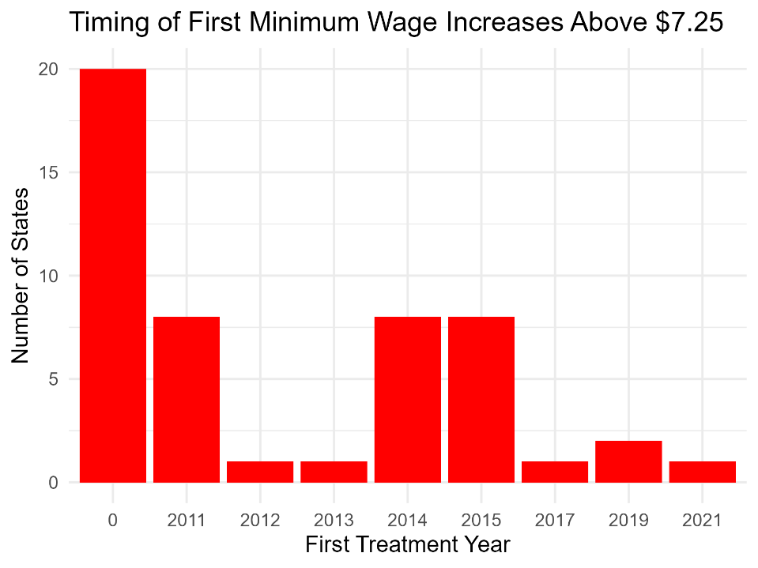
Figure 2: Timing of first state minimum wage increases above the federal minimum. This figure depicts the distribution of the first year in which states raised their statutory minimum wage over the federal minimum of $7.25. States that did not raise their minimum wage throughout the study period are clustered at zero. The significant variability in adoption date necessitates the employment of staggered difference-in-differences approaches and dynamic event-study analysis.

Results from the covariate-adjusted two-way fixed effects (TWFE) specification are shown in Table 2. The state-year poverty rate among full-time low-wage workers (poverty_rate_pct) is the dependent variable. State fixed effects (STATEFIP), year fixed effects, population weights (pop_weight), and standard errors clustered at the state level are all included in the model. Standardized measures of educational attainment (z_share_lowedu), unemployment (z_unemp), SNAP participation (z_snap), and racial composition (z_share_nonwhite) are examples of covariates utilized in our analysis. There is no statistically significant correlation between minimum wage levels and poverty in this formulation, according to the calculated coefficient on the log real minimum wage (log_minw_real), which is 1.15 with a standard error of 1.54. The estimate suggests a broad confidence range that encompasses both mild rises and decreases in poverty. With a coefficient of 0.68 (SE = 0.27, p < 0.05), SNAP enrollment is positively and statistically substantially correlated with poverty among the variables. Conventional standards of statistical significance do not apply to other factors. With a within-state R-squared of 0.028 and 700 state-year data, the regression indicates that within-state variance in poverty is still substantially unexplained in a TWFE framework even after adjusting for observable state-level circumstances. Staggered difference-in-differences approaches that specifically take treatment timing and dynamic responses into consideration are encouraged by these findings.

Term | Estimate | Std. error
Log real minimum wage | 1.15 | 1.54
Share with less than high school (standardized) | 0.48 | 0.34
Unemployment rate (standardized) | 0.43 | 0.34
Share receiving SNAP (standardized) | 0.68** | 0.27
Share nonwhite (standardized) | -0.43 | 0.28
Table 2. Covariate-adjusted two-way fixed effects estimates. Covariate-adjusted two-way fixed effects estimates of the association between poverty and minimum wage levels among full-time low-wage workers are presented in this table. Coefficients are presented with standard errors. Statistical significance is shown as *** p < 0.01, ** p < 0.05, and * p < 0.10. The estimated coefficient on log real minimum wage is not statistically significant, whereas SNAP participation is positively and significantly associated with measured poverty, emphasizing the importance of household and safety-net characteristics over wage floors. Clustered by state including state and year fixed effects.

The staggered difference-in-differences estimator of Callaway and Sant'Anna (2021) with covariate adjustment is used to obtain the main findings. The first year that a state raises its statutory minimum wage in comparison to its own previous year's level is referred to as treatment. The aggregated average treatment effect on the treated (ATT) is shown in Table 3. With a standard error of 3.16 and a 95% confidence range of [−10.95, 1.43], the total covariate-adjusted ATT is −4.76 percentage points. This estimate's size indicates economically substantial decreases in poverty after minimum wage rises, even if it is not statistically significant at the 5 percent level.
It should be noted that significant variation may be seen in estimates broken down by treatment cohort. While states treated in 2015 show a statistically significant drop of −6.62 percentage points (SE = 3.02), with a 95 percent confidence interval of [−12.73, −0.51], states initially treated in 2011 see an estimated reduction of −8.88 percentage points (SE = 5.97). States that were initially treated in 2014, on the other hand, had a tiny and statistically insignificant positive estimate of 1.23 (SE = 4.01). These findings suggest that in some adoption cohorts, raising the minimum wage is linked to significant decreases in poverty, although the benefits differ significantly depending on the time of treatment.

Group | ATT (percentage points) | Std. error | 95% CI (low) | 95% CI (high)
Overall Average Treatment Effect on the Treated Group | -4.76 | 3.16 | -10.95 | 1.43
First treated in 2011 | -8.88 | 5.97 | -20.59 | 2.82
First treated in 2014 | 1.23 | 4.01 | -6.63 | 9.10
First treated in 2015 | -6.62 | 3.02 | -12.54 | -0.71
Table 3. Covariate-adjusted staggered DiD estimates (aggregated ATT). This table uses the Callaway and Sant'Anna framework to give covariate-adjusted staggered difference-in-differences estimates. The average treatment effects on the treated (ATT) are stated in percentage points, with 95 percent confidence intervals provided. Statistical significance is shown as *** p < 0.01, ** p < 0.05, and * p < 0.10. The overall ATT is negative but imprecisely assessed, but cohort-specific estimates show variation across adoption time, including a statistically significant poverty reduction for the 2015 cohort.

Dynamic event-study estimates from the covariate-adjusted staggered difference-in-differences model are shown in Figure 3. Pre-treatment coefficients are tiny and statistically insignificant from four years before treatment to the year right before treatment. For instance, there is no indication of differing pre-treatment trends because the estimate at event_time = −1 is 3.44 (SE = 2.97) and confidence intervals consistently encompass zero throughout all pre-treatment periods.
Instead of emerging right away, post-treatment effects take time to manifest. Estimated effects are limited and imprecise over the first two years after therapy. Estimates start to decline in the third year following treatment, with an impact of −6.57 percentage points at event_time = 3 (SE = 3.34). Longer horizons provide larger negative point estimates, such as −13.14 at event_time = 5 and −9.20 at event_time = 8, but later periods have fewer data, which causes confidence intervals to significantly expand. Generally, the dynamic pattern indicates that poverty reductions linked to increases in the minimum wage happen gradually and change over time, which is consistent with gradual changes in household income, earnings, and hours rather than rapid policy effects. It should be known that each event_time estimate was not statistically significant, in addition to the ATT, but the ATT does not have a confidence interval spanning over zero.
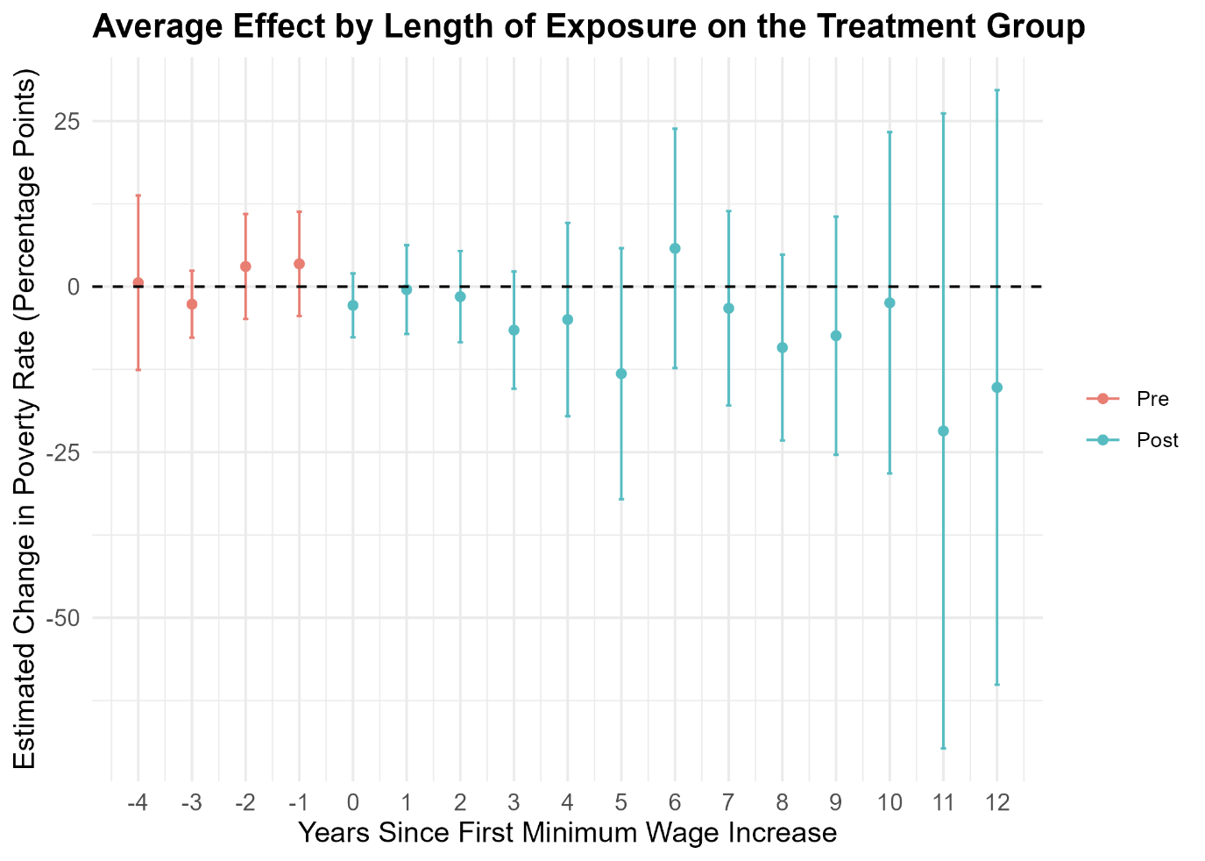
Figure 3: Dynamic treatment effects of minimum wage increases on poverty. This graph depicts event-study results from the covariate-adjusted staggered difference-in-differences model. Points show the average treatment impacts on the treated at each event time in comparison to the year before the first minimum wage rise, with vertical bars denoting 95 percent confidence intervals. Pre-treatment estimates are centered at 0 and statistically indistinguishable from zero, confirming the parallel trends hypothesis. Post-treatment impacts vary and are imprecisely calculated, implying that any poverty response to minimum wage rises is minor and lacks an obvious or apparent pattern.

Across specifications, covariate-adjusted fixed effects models find no statistically significant contemporaneous link between minimum wage levels and poverty. On the other hand, for some adoption cohorts, economically significant but imprecisely estimated poverty reductions are shown by staggered difference-in-differences estimates that take treatment time and dynamics into account. The findings of event studies suggest that policy impacts develop gradually rather than instantly and do not provide any indication of distinct pre-treatment trends. For completeness, baseline and non-covariate-adjusted estimates are presented in the Appendix and produce qualitatively comparable patterns.
Conversely, the staggered difference-in-differences estimates show greater negative point estimates when treatment timing and dynamic effects are explicitly accounted for. Although the estimate is imprecise, the aggregated covariate-adjusted ATT shows an average poverty decrease of about 4.8 percentage points after minimum wage rises. Additionally, cohort-specific estimates demonstrate statistically significant decreases in poverty in states that raise the minimum wage in a specific year, as seen with the year 2015. These results highlight the significance of accounting for adoption cohort variability and imply that the impact of minimum wage policies may vary depending on the state of the economy at the time of implementation.
The timing of policy consequences is further clarified by dynamic event-study results. The parallel trends assumption that underpins the staggered difference-in-differences design is validated by the lack of statistically significant pre-treatment effects. Larger negative point estimates develop many years after the initial increase, and post-treatment estimates show that poverty reductions occur gradually rather than instantly. This pattern is consistent with slow changes in household income, labor supply, and wages that may take some time to show up in changes in assessed poverty status.
Discussion and Interpretation
While investigating state-year data from 2010 to 2023 with contemporary difference-in-differences techniques, the findings indicate that raising the minimum wage may eventually lead to economically significant cuts in poverty for some cohorts, but they are not linked to rapid or consistent decreases in measured poverty across specifications.
Looking at the covariate-adjusted two-way fixed effects, the estimates show no statistically significant contemporaneous relationship between minimum wage levels and poverty. This finding is consistent with prior research indicating that fixed effects models often fail to capture heterogenous or delayed policy impacts when treatment timing varies across units. In this context, the lack of significance should not be interpreted as evidence of no effect, but rather as a limitation of estimators that implicitly average over treatment and cohorts timing.
Furthermore, the timing of policy impacts is further clarified by dynamic event-study results. The parallel trends assumption that underpins the staggered difference-in-differences design is validated by the lack of statistically significant pre-treatment effects. Larger negative point estimates develop many years after the initial increase, and post-treatment estimates show that poverty reductions occur gradually rather than instantly. This pattern is consistent with slow changes in household income, labor supply, and wages that may take some time to show up in changes in assessed poverty status.
Despite indications of salary gains and improved material situations, the results are consistent with earlier research showing modest or unclear impacts of minimum wage rises on official poverty metrics. According to the study conducted by Sabia and Burkhauser (2010), pay ceilings cannot significantly alleviate poverty since many people living in poverty do not work full-time. Poverty status is largely determined by household composition, hours worked, and non-wage income sources, even among full-time low-wage workers. Evidence that linked outcomes, including food insecurity, may react more clearly than official poverty rates is consistent with the slow and varied impacts seen here (Winkler et al., 2025). All of these results point to the possibility that welfare gains from minimum wage policies may be underestimated by poverty metrics.
There are several variables that might explain why poverty impacts are limited and imprecisely evaluated. First, the federal poverty line is a crude assessment that does not account for local differences in living costs or in-kind assistance. As a result, pay rises that significantly boost household resources may be overlooked in official poverty figures. Second, minimum wage rises may result in changes in hours worked or household labor supply that counterbalance hourly pay gains, especially in high-cost jurisdictions. Third, treatment effects may differ significantly between states due to baseline pay distributions, labor market circumstances, and complementing policies, resulting in large confidence ranges in aggregated results. Likewise, the research focuses on state-level averages for full-time low-wage workers. While this strategy enhances the significance of minimum wage exposure, it may obscure individual-level transitions into and out of poverty, further dampening estimated impacts.
Based on the results, it is doubtful that increasing the minimum wage on its own will result in significant or quick decreases in measured poverty among full-time low-wage workers. However, the evidence of economically significant poverty reductions for certain cohorts and over longer time horizons suggests that minimum wage policies can help to improve outcomes under certain situations. These findings provide credence to the notion that minimum wage increases are most successful when accompanied with complementing policies, such as targeted tax credits or social assistance programs, that directly address household resources and cost-of-living disparities.

Limitations
Several factors should be considered when interpreting this study's conclusions. The research is based on state-year aggregated outcomes, which is acceptable given that minimum wage policies are implemented at the state level, but it may obfuscate individual-level transitions into and out of poverty. This grouping may obscure variable reactions among workers and families with varying compositions and income sources. The use of the official poverty measure limits interpretation even further. Because the federal poverty line does not account for geographic cost-of-living disparities, in-kind benefits, or informal income, pay increases that enhance household resources may not result in significant improvements in poverty status. As a result, calculated effects may underestimate the overall welfare effects of minimum wage rises.
Moreover, treatment effects vary between adoption cohorts, indicating changes in baseline labor market circumstances and regulatory contexts between states. While the staggered difference-in-differences approach allows for variable timing and dynamic responses, the study cannot fully untangle the individual state-level elements generating this variation. Lastly, estimates of long-run impacts are inaccurate for states that raise minimum wages later in the sample period, since dynamic event-study coefficients over longer time horizons are based on fewer data. Although pre-treatment trends are statistically indistinguishable from zero, causal interpretation is still based on the premise that no unobserved time-varying causes coincide with policy implementation.

Conclusion
Minimum wage legislation is typically characterized as a key instrument for poverty reduction, although empirical data on its effectiveness remains mixed, especially when poverty is quantified at the household level. Using state-year data from 2010 to 2023 and current difference-in-differences methodologies that account for staggered policy implementation, this study presents an improved evaluation of the relationship between state minimum wage hikes and poverty among full-time low-wage workers. The results show that increases in the minimum wage are not related to quick or uniform decreases in measured poverty. Covariate-adjusted fixed effects models demonstrate no statistically significant contemporaneous association, but staggered difference-in-differences estimates suggest economically relevant, if inaccurate, poverty reductions for certain adoption cohorts. Event-study findings indicate no indication of distinct pre-treatment trends, implying that any poverty consequences arise gradually rather than immediately after policy changes. These findings emphasize the potential and limitations of minimum wage policies as anti-poverty measures. While pay ceilings can help to improve outcomes under certain economic situations and over longer time horizons, they are unlikely to result in considerable or consistent poverty reductions on their own when measured using official poverty metrics. Household composition, labor supply adjustments, and complementing policies all play an important role in deciding whether wage increases lead to poverty reduction.
Overall, the findings emphasize the significance of proper empirical design for analyzing staggered policy interventions and warns against deriving strong conclusions from models that do not account for treatment timing and variation. As minimum wage law evolves among states, future research should include individual-level data, longer time horizons, and connections with other social policies to support successful and focused anti-poverty efforts.

Appendices

Appendix Table A1. Baseline two-way fixed effects estimates
Term | Estimate | Std. error
Log real minimum wage | 1.21 | 1.63
This table reports baseline two-way fixed effects estimates without covariate adjustment. Coefficients are reported with standard errors. This was used as a baseline to compare with the results in Table 2.

Appendix Table A2. Baseline staggered DiD estimates (aggregated ATT)
Group | ATT (percentage points) | Std. error | 95% CI (low) | 95% CI (high)
Overall ATT | -0.12 | 1.00 | -2.08 | 1.84
First treated in 2011 | 0.86 | 1.15 | -1.39 | 3.11
First treated in 2014 | -2.03 | 1.43 | -4.83 | 0.76
First treated in 2015 | 0.81 | 2.54 | -4.17 | 5.78
This table shows the aggregated staggered difference-in-differences estimates without covariate correction. The average treatment effects on the treated are presented in percentage points, with statistical significance marked by *** p < 0.01, ** p < 0.05, and *p < 0.10. The findings are presented to demonstrate how covariate correction influences the size and accuracy of estimates in comparison to the main results in Table 3.

References
Arranz, J. M., & García-Serrano, C. (2025). Assessing the impact of an increase in the minimum wage on household income and poverty. Social Science Research, 127, 103143. https://doi.org/10.1016/j.ssresearch.2025.103143
Bilinski, A., & Hatfield, L. A. (2020). Nothing to see here? Non-inferiority approaches to parallel trends and other model assumptions. arXiv. https://arxiv.org/abs/1805.03273.
Callaway, B., & Sant’Anna, P. H. C. (2021). Difference-in-differences with multiple time periods. Journal of Econometrics, 225(2), 200–230. https://www.sciencedirect.com/scien ce/article/abs/pii/S0304407620303948?via%3Dihub.
Dube, A., Lester, T. W., & Reich, M. (2010). MINIMUM WAGE EFFECTS ACROSS STATE BORDERS: ESTIMATES USING CONTIGUOUS COUNTIES. The Review of Economics and Statistics, 92(4), 945–964. http://www.jstor.org/stable/40985804.
Federal Reserve Bank of St. Louis. (2024). Consumer Price Index for All Urban Consumers: All Items in U.S. City Average (CPI-U) [CPIAUCSL]. https://fred.stlouisfed.org/series/CPIA UCSL.
Feng, S., Ganguli, I., Lee, Y., Poe, J., Ryan, A., & Bilinski, A. (2024). Difference-in-differences for health policy and practice: A review of modern methods. arXiv. https://arxiv.org/ab s/2408.04617.
MacKinnon, J. G., Nielsen, M. Ø., & Webb, M. D. (2023). Testing for the appropriate level of clustering in linear regression models. Journal of Econometrics, 235(2), 2027–2056. https://doi.org/10.1016/j.jeconom.2023.03.005.
Narain, K. D. C., & Zimmerman, F. J. (2019). Examining the association of changes in minimum wage with health across race/ethnicity and gender in the United States. BMC Public Health, 19(1), 1069. https://doi.org/10.1186/s12889-019-7376-y
R Core Team. (2023). R: A Language and Environment for Statistical Computing. R Foundation for Statistical Computing, Vienna, Austria. https://www.r-project.org/.
Sabia, J. J., & Burkhauser, R. V. (2010). Minimum Wages and Poverty: Will a $9.50 Federal Minimum Wage Really Help the Working Poor? Southern Economic Journal, 76(3), 592–623. http://www.jstor.org/stable/27751487.
U.S. Bureau of Economic Analysis. (2024). State Annual Summary Statistics. https://tinyurl. com/2r6jfax5.
U.S. Bureau of Labor Statistics. (2024). Local Area Unemployment Statistics (LAUS). https://ww w.bls.gov/lau/.
U.S. Department of Labor, Wage and Hour Division. (2024). Changes in Basic Minimum Wages in Non-Farm Employment Under State Law: Selected Years 1968 to 2024. https://www.d ol.gov/agencies/whd/state/minimum-wage/history.
Wang, W., Phillips, P. C. B., & Su, L. (2019). The heterogeneous effects of the minimum wage on employment across states. Economics Letters, 174, 179–185. https://doi.org/10.1016/j. econlet. 2018.11.002.
Winkler, M. R., Clohan, R., Komro, K. A., Livingston, M. D., & Markowitz, S. (2025). State minimum wage and food insecurity among US households with children. JAMA Network Open, 8(3), e252043. https://doi.org/10.1001/jamanetworkopen.2025.2043.

